**Topic for Project**

**Analyze the Attrition rate of Employees**

Problem Statement:

Organizations are realizing  that  employees are valuable  assets. So the HR manager’s role  in the  present era was prominent. Employees in this era are  more often eager to jump from one to another because of some many reasons. Hence employee attrition has become a major factor in estimating the organization efficiency. Attrition is a major concern for organizations because functioning of the organization entirely depends on the pool of employees. Attrition rate defines the organization’s image. Higher the attrition rate the organization has to face some incurred costs to recruit, induct, placement and train the employee. **Ashna Group facing an employee attrition problem**.

Data description:

The dataset contains 26 columns/factors and 1,470 rows/observations.

The dataset consists of factors or reasons that can lead to attrition of employees

Different columns are

**C 🡪 BusinessTravel (3) -**Non-Travel, Travel_Rarely, Travel_Frequently

**C 🡪 Department -**Human Resource, Research & Development, Sales

**C 🡪 Education (5) -**1- 'Below College', 2- 'College', 3- 'Bachelor', 4- 'Master', 5- 'Doctor'

**C 🡪 EducationField (6) -**Human Resource, Life Sciences, Medical, Marketing, Technical Degree, Others

**C 🡪 EnvironmentSatisfaction (4) -**1 - 'Low', 2 - 'Medium', 3 - 'High', 4 - 'Very High'

**C 🡪 Gender (2) -** Male or Female

**C 🡪 JobInvolvement (4) -**1 - 'Low', 2 - 'Medium', 3 - 'High', 4 - 'Very High'

**C 🡪 JobRole (9) -**Human Resource**,**Sales Executive, Research Scientist, Laboratory Technician, Manufacturing Director, Healthcare Representative, Manager, Sales Representative, Research Director

**C 🡪 JobSatisfaction (4) -**1 - 'Low', 2 - 'Medium', 3 - 'High', 4 - 'Very High'

**C 🡪 MaritalStatus (3) -**Single, Married, Divorced

**C 🡪 OverTime (2) -**Yes or NO

**C 🡪 PerformanceRating (4) -**1 - 'Low', 2-  'Good', 3 - 'Excellent', 4- 'Outstanding'

**C 🡪 RelationshipSatisfaction (4) -**1 - 'Low', 2 - 'Medium', 3 - 'High', 4 - 'Very High'

**C 🡪 WorkLifeBalance (4) -**1- 'Bad' , 2 - 'Good', 3 - 'Better', 4 - 'Best'

**N 🡪 PercentSalaryHike -**Percentage hike in the salary of employees

**N 🡪 TotalWorkingYears -**Total experience of the employees

**N 🡪 Age -**Age of Employee

**N 🡪 DistanceFromHome -**Office distance from Home of employees

**N 🡪 MonthlyIncome -**Monthly income of employees in dollar value ($)

**N 🡪 NumCompaniesWorked -**Number of companies where employee has worked

**N 🡪 YearsAtCompany -**Number of years since the employee has joined

**N 🡪 YearsInCurrentRole -**Number of years in the current job role

**N 🡪 YearsWithCurrManager -**Number of years with the current manager

Questions:

1. You are the Business Analyst at Ashna Group and have to make a report  to solve the problem of attrition.
2. Uncover the factors that lead to employee attrition.
3. Show **graphically** using density charts:
4. Show influence of different factors on attrition rate
5. Which department is facing a major attrition problem.
6. Show a breakdown of distance from home by job role and attrition’
7. compare average monthly income by education and attrition
8. Provide few solutions to the problem of attrition at the company.
9. Consider the %age to compare the Attrition Rate among different features rather than direct numbers.
10. Q.1 🡪 Heat Maps to determine the correlated pairs

Scatter Pair Plot/ Density Chart

1. Points should be supported with some graphs and headings

An organization was experiencing a high turnover rate among new hires. Many employees left the company before the end of their first year on the job. The analysts used the data analysis process to answer the following question: **how can the organization improve the retention rate for new employees?**

Here is a break down what this team did, step by step.



First up, the analysts needed to define what the project would look like and what would qualify as a successful result. So, to determine these things, they **asked** effective questions and collaborated with leaders and managers who were interested in the outcome of their people analysis. These were the kinds of questions they asked:

* What do you think new employees need to learn to be successful in their first year on the job?
* Have you gathered data from new employees before? If so, may we have access to the historical data?
* Do you believe managers with higher retention rates offer new employees something extra or unique?
* What do you suspect is a leading cause of dissatisfaction among new employees?
* By what percentage would you like employee retention to increase in the next fiscal year?

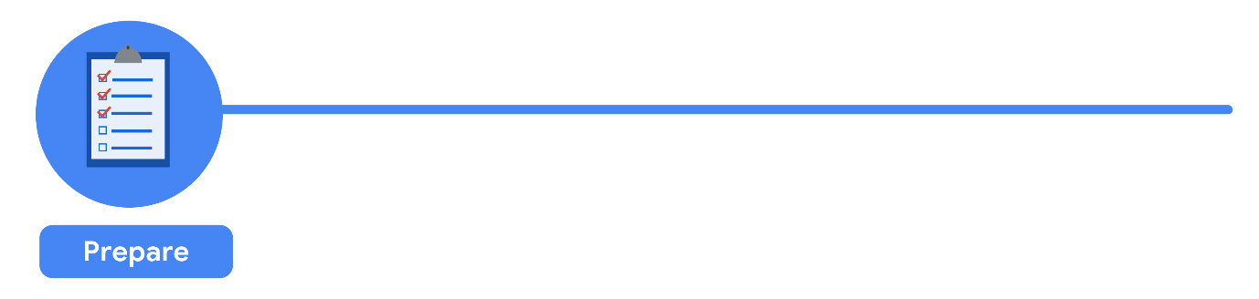

It all started with solid **preparation**. The group built a timeline of three months and decided how they wanted to relay their progress to interested parties. Also during this step, the analysts identified what data they needed to achieve the successful result they identified in the previous step - in this case, the analysts chose to gather the data from an online survey of new employees. They developed specific questions to ask about employee satisfaction with different business processes, such as hiring and onboarding, and their overall compensation. Rules were established for who would have access to the data collected - in this case, anyone outside the group wouldn't have access to the raw data, but could view summarized or aggregated data. For example, an individual's compensation wouldn't be available, but salary ranges for groups of individuals would be viewable. They finalized what specific information would be gathered, and how best to present the data visually. The analysts brainstormed possible project- and data-related issues and how to avoid them.

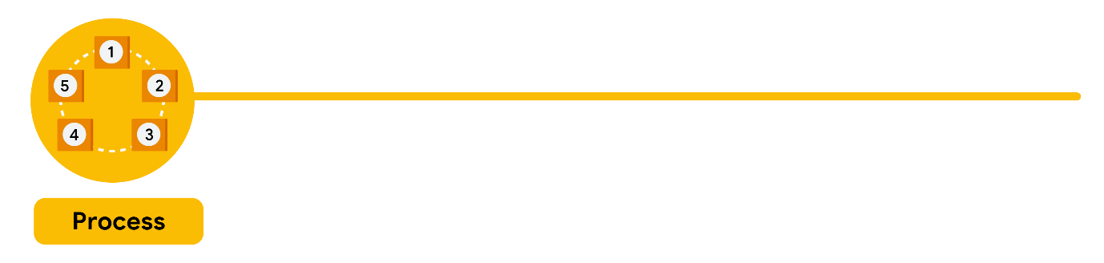

The group sent the survey out. Great analysts know how to respect both their data and the people who provide it. Since employees provided the data, it was important to make sure all employees gave their consent to participate. The data analysts also made sure employees understood how their data would be **collected, stored, managed, and protected**. In order to maintain confidentiality and protect and store the data effectively, access was restricted to a limited number of analysts. Collecting and using data ethically is one of the responsibilities of a data analyst. Then the data was cleaned to make sure it was complete, correct, and relevant. Certain data was aggregated and summarized without revealing individual responses. The raw data was uploaded to an internal data warehouse for an additional layer of security.

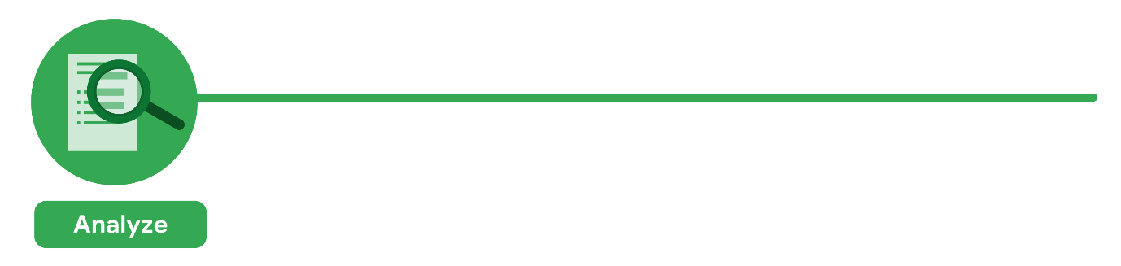

Then, the analysts did what they do best: analyze! From the completed surveys, the data analysts would **discover** that a new employee’s experience with certain processes was a key indicator of overall job satisfaction. The analysts found that employees who experienced a long and complicated hiring process were most likely to leave the company. Employees who experienced an efficient and transparent evaluation and feedback process were most likely to remain with the company. The group knew it was important to **document** exactly what they found in the analysis, no matter what the results. To do otherwise would diminish trust in the survey process and reduce their ability to collect truthful data from employees in the future.



Just as they made sure the data was carefully protected, the analysts were also careful **sharing the report**. Only the managers who met or exceeded the minimum number of direct reports with submitted responses to the survey were eligible to receive the report. The group first presented the results to eligible managers to make sure they had the full picture. Then, they asked them to deliver the results to their teams. This gave the managers an opportunity to **communicate the results** with the right context. As a result, they could have productive team conversations about next steps to improve employee engagement.

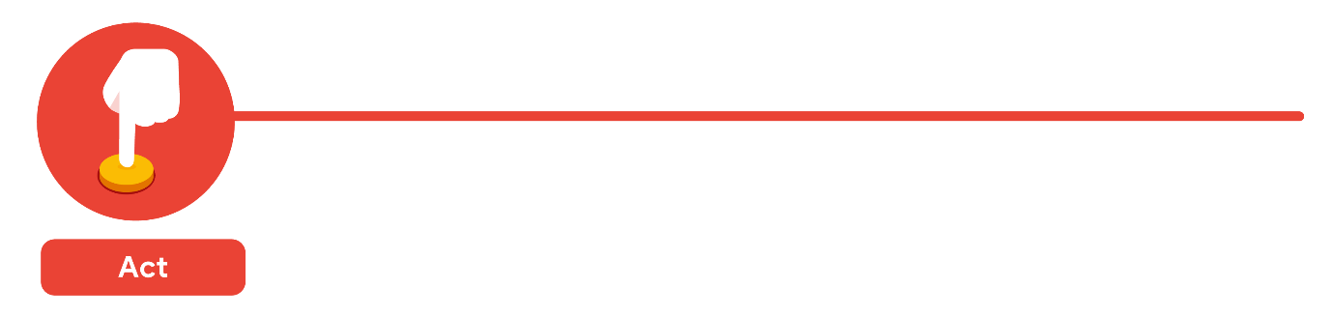

The last stage of the process for the team of analysts was to work with leaders within their company and decide how best to **implement changes and take actions** based on the findings. The analysts recommended standardizing the hiring and evaluation process for all new hires based on the most efficient and transparent practices. A year later, the same survey was distributed to employees. Analysts anticipated that a comparison between the two sets of results would indicate that the action plan worked. Turns out, the changes improved the retention rate for new employees and the actions taken by leaders were successful!